Tab 1
Bhavna Kakar
Presents
Ekta Singha|Madhav Vyas|Mansoor N. Mansoori
Retrospective Analysis of Memory, Figment and Nostalgia

Preview: 18th December, 2024 | Wednesday I All Day Preview
Timing: 12 PM onwards

Exhibition Open till: 18th January, 2025
Timings: Monday to Saturday, 11 AM – 7 PM

Venue: Gallery LATITUDE 28, F - 208, F/F, Lado Sarai, New Delhi

LATITUDE 28 invites viewers to re-examine the nature of memory and the complex emotional relationship we share with our memories. The result is an exhibition that unites artists whose works go beyond mere recollection to contemplate the ways that individual and collective memories come together and shape perception. Using mixed media, painting, and photographs, the artists explore the mutability of time, past distortion, and nostalgia's function in identity construction.
Retrospective Analysis of Memory, Figment, and Nostalgia is a three-person exhibition and the last of 2024 by LATITUDE 28, delving into the intricate interplay between memory and identity and the experiential nature of existence. This exhibition interrogates how memories shape both individual and collective conceptions of self, with contributions by Ekta Singha, Madhav Vyas, and Mansoor N. Mansoori offering nuanced perspectives. Their works explore the fluid, fragmented, and often elusive qualities of memory, challenging linear perceptions and inviting viewers to consider how past experiences and emotional resonances continually shape the present.
Ekta Singha’s practice is deeply rooted in the investigation of memory as a determinant of both personal and collective histories. Through mixed media, she dissolves the boundaries between past and present, creating works that blur temporal distinctions. Her art evokes nostalgia while highlighting the emotional weight of memories, which may be fleeting, distorted, or fragmented. Singha’s exploration of the recreation of memory encourages reflection on how these processes shape individual identity and our engagement with cultural heritage, offering profound commentary on the tenuous nature of remembering and its implications for the self.
Madhav Vyas examines the theme of nostalgia through an exploration of the delicate relationship between time and space. Employing painting and photography, Vyas crafts vivid impressions of visual terrains that evoke sensations of suspended moments—memories sensed but not fully recalled. His works engage with the collective processes of remembering, forgetting, and archiving, portraying memory as dynamic and mutable. Vyas’s approach underscores how our past is continuously constructed and reconstructed, imbued with emotional significance that shapes both personal and shared histories.

Mansoor N. Mansoori’s practice interrogates the reliability of memory, particularly its susceptibility to distortion, erosion, and transformation over time. Employing a blend of digital and sculptural media, Mansoori captures the tension between the real and the imagined. His works probe the psychological landscapes shaped by memory, exploring its transient and mutable character through technological manipulation. Mansoori’s art underscores the fragility of remembrance and its influence on individual and collective identity, inviting contemplation of the forms through which we experience and preserve memory.

The exhibition invites a quiet moment to think about how personal memories mix with collective ones - what we go through alone is also something we share with others. It uncovers the tangled ways we remember and forget, how our past keeps getting rewritten, and how imagination helps us create the stories we live by.

Quote by Bhavna Kakar
I am delighted to present the final chapter in LATITUDE 28’s 2024 trilogy of exhibitions,
following ‘A LATITUDE 28 TRILOGY: Medium, Manifestation, and Manipulation’ and ‘A LATITUDE 28 TRILOGY: Fragile’. Staying true to our commitment to showcasing fresh talent, ‘Retrospective Analysis of Memory, Figment, and Nostalgia’ is a three-artist exhibition that concludes our year’s programming. This evocative show delves into the fluid, fragmented nature of memory, challenging the conventional, linear notions of time and exploring how past experiences and emotions shape the present. It features the thought-provoking works of Ekta Singha, Madhav Vyas, and Mansoor N. Mansoori.

Have you ever reflected on how memories define who we are? This exhibition invites you to pause and explore the delicate, elastic quality of memory. By unraveling the intricate threads of nostalgia and perception, the show encourages viewers to engage with the complexities of recollection—like assembling a puzzle with missing or shifting pieces. This is what makes memory so fascinating and what makes this exhibition a deeply meaningful exploration of our collective and personal identities.

– Bhavna Kakar, Founder-Director, LATITUDE 28

Artists

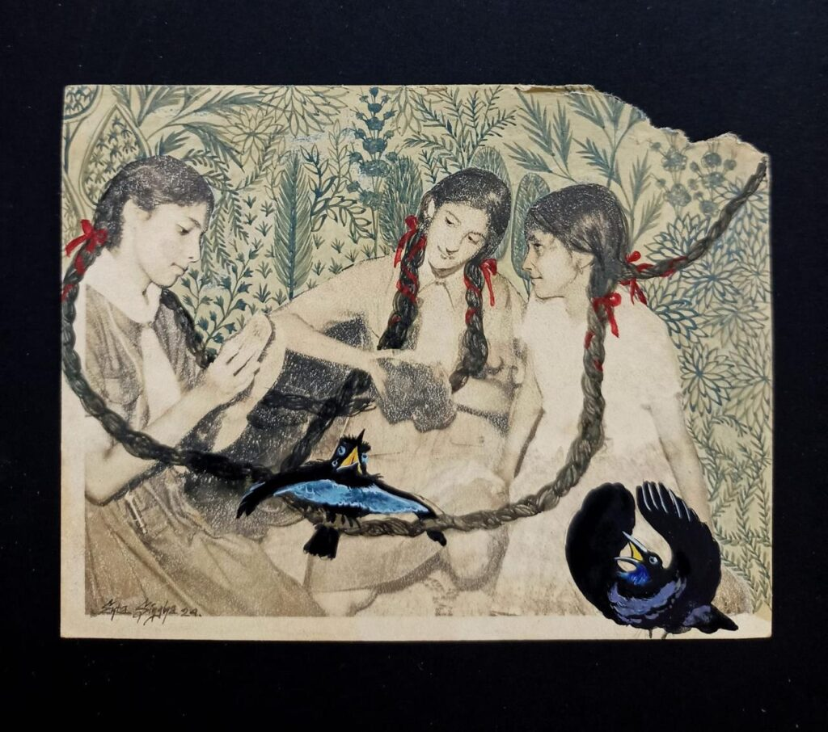
Ekta Singha, 2024, Hera Pheri, Gouache, natural pigment on found photographs of 1960, 3.6 x 4.5 inches
Ekta Singha is an artist whose art practice explores overlaps of memory, identity, and cultural heritage. She graduated with a Bachelor's degree in painting from the Government College of Art and Craft in Kolkata and her Master's in Fine Arts with a specialization in Murals from the Faculty of Fine Arts at MSU, Baroda (Gujarat, India). Her works have been exhibited at various group exhibitions and projects, including ‘Retrospective Analysis of Memory, Figment and Nostalgia’, curated by Bhavna Kakar at LATITUDE 28 (2024); the 15th Edition of India Art Fair presented by Gallerie Splash, curated by Satyajit Dave (2024); and India Art Fair with Art Centrix Space Gallery, New Delhi, in (2018 and 2019).

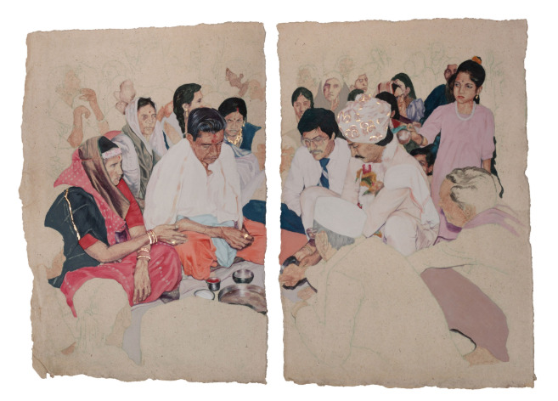
Madhav Vyas,2023, Placid Proceedings XII & XII (Set of Two), Gouache and Gold foil on Vasli, 11.5 x 8.5 inches (each)

Madhav Vyas is a visual artist from Bhavnagar, Gujarat, and is currently based in Baroda. He completed his Bachelor’s degree (2014-18) in painting and a Master’s degree (2019-21) from the Graphics Department, Faculty of Fine Arts at MSU, Baroda. His practice emerges from the characters, events, and stories of his family. He presented his works in various group shows: ‘Retrospective Analysis of Memory, Figment and Nostalgia’, curated by Bhavna Kakar at LATITUDE 28 (2024); and ‘Embark IV/V’ with Ark Foundation for the Arts at Vadodara in May (2023); ‘The Flying Goat’ show at Goa in April (2022).

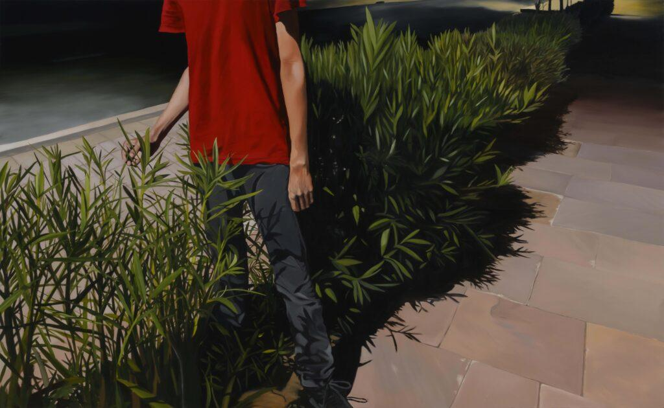
Mansoor N. Mansoori, 2022, Solace, oil on canvas, 48 x 78 inches
Mansoor N. Mansoori is a visual artist working with painting, video, photography, printmaking, and immersive light installations. He completed his Bachelor’s in Visual Arts (Painting) at the Faculty of Fine Arts from the Maharaja Sayajirao University of Baroda, Gujarat, and his Master’s in Fine Arts, Department of Art and Performing Arts, from Shiv Nadar University, Dadri, Uttar Pradesh. His work focuses on various issues related to technology, ecology, and emotional suffering. His recent works extensively focus on the vulnerable human presence in urban landscapes and are showcased in an exhibition, ‘Retrospective Analysis of Memory, Figment and Nostalgia’, curated by Bhavna Kakar at LATITUDE 28 (2024); ‘I, Non-I and the Other,’ curated by Sibdas Sengupta with Wetlands Art Space at Shiv Nadar University, Dadri (2023); and ‘Revisions On The Surface,’ curated by Premjish Achari, at Gallery Dotwalk, Gurgaon (2022).
About LATITUDE 28

Since 2010, LATITUDE 28 has probed into a gallery practice that is lateral, disruptive and avant-garde. Mentoring and nurturing emerging artists from South Asia, the gallery focuses on experimentation with medium and material fostering critical dialogue, perspective and practices by writers, critics and researchers alike. These maker-market relationships amongst collectors, art enthusiasts and art practitioners have grown through the gallery’s interactive incubation space, where ideas have been generated through innovative curatorial projects located on the cusp of art history and socio-political context through site-specific artworks and artist talks. The gallery makes art accessible and inclusive with exhibitions located at the intersection of artists, institutions and art education. LATITUDE 28’s vision is shaped by its Founder/Director, Bhavna Kakar, who is also the Founder and Editor-in-Chief of TAKE on Art - South Asia’s leading contemporary art publication.

SOCIAL MEDIA HANDLES
Facebook: https://www.facebook.com/GalleryLatitude28
Instagram: @latitude_28 @bhavz15 @takeonart

FOR MEDIA QUERIES
Longform, India
Pooja Gulati : pooja.gulati@longform.in | +91 98104 62407

